The University of Azad Jammu and Kashmir, Muzaffarabad

Name: Alishba Zakir
Roll No: 2024-SE-02
Course: DataBase Systems
Course Code: CS-2204
Lab: 09
Submitted To: Engr. Awais Rathore
Submitted By: Alishba Zakir
Date: April , 2026

Department Of Software Engineering

Join Part 2
1. Self Join
A self join is not a separate SQL command; it uses standard join types (like INNER JOIN or LEFT JOIN) but applies them to the same table. Because you are using one table twice, you must use table aliases to give them unique names so SQL can tell them apart.
2. Multiple Table Join
A multiple table join happens when you need to pull related data scattered across three or more distinct tables. You achieve this by chaining JOIN statements one after another. SQL processes these logically from top to bottom, joining the result of the first pair to the next table.

B1: Employee+Manager
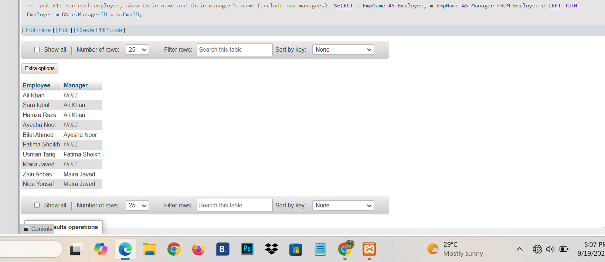
B2:Employee Earning more than manager
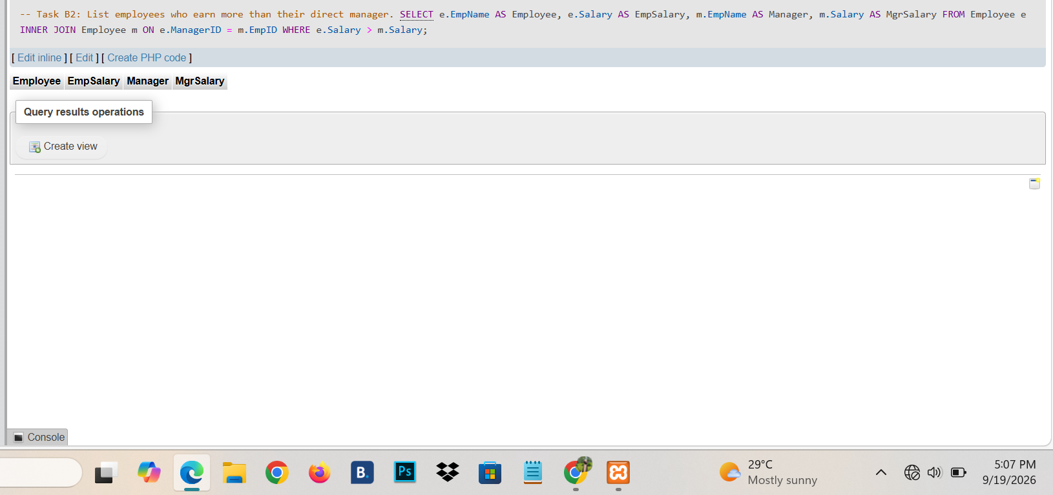
B3: Manager different Department :
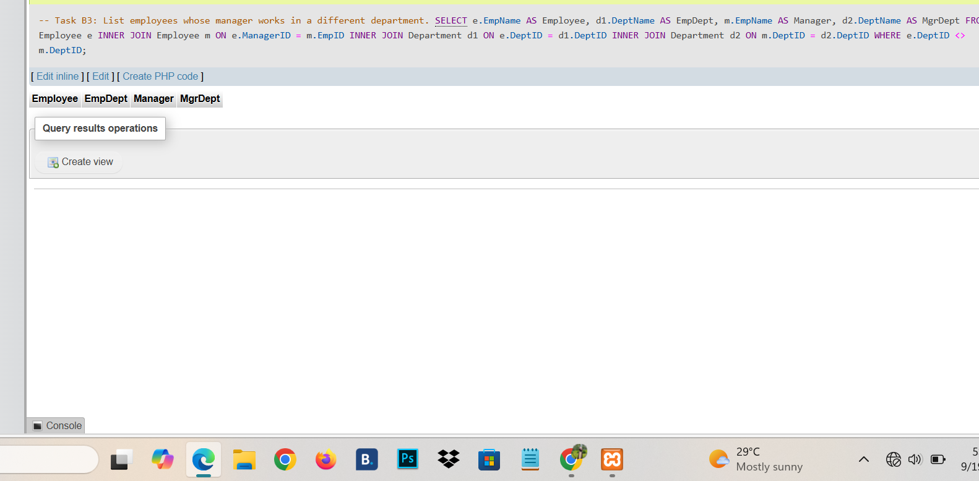
B4: Employee+Project+Hours
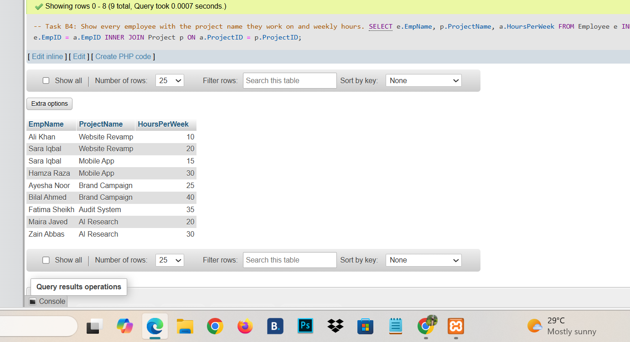
B5: Assignment+ Employee+Project+Department
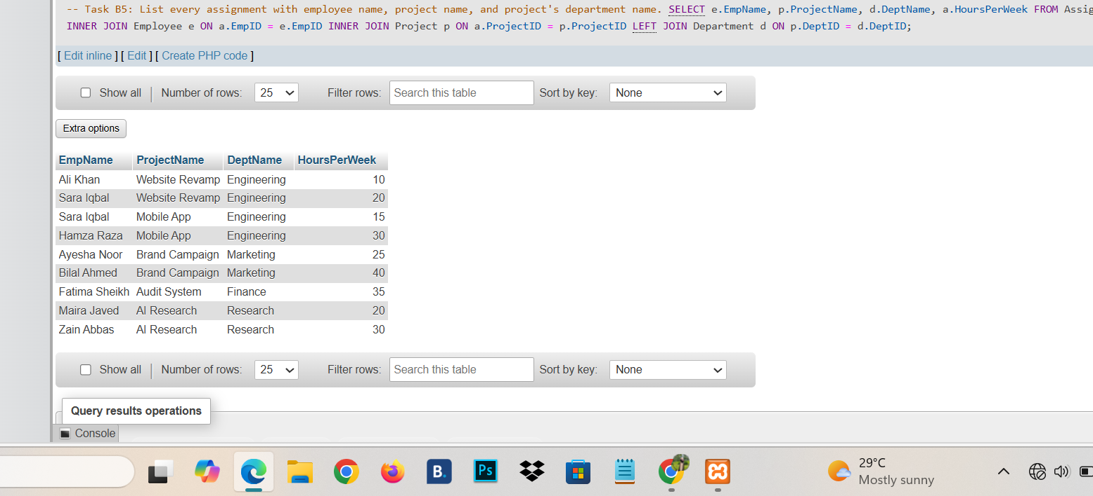
B6: Mobile App Project
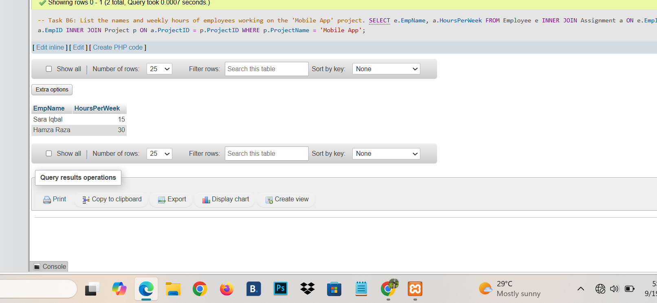
B7: Lahore employee+ Project
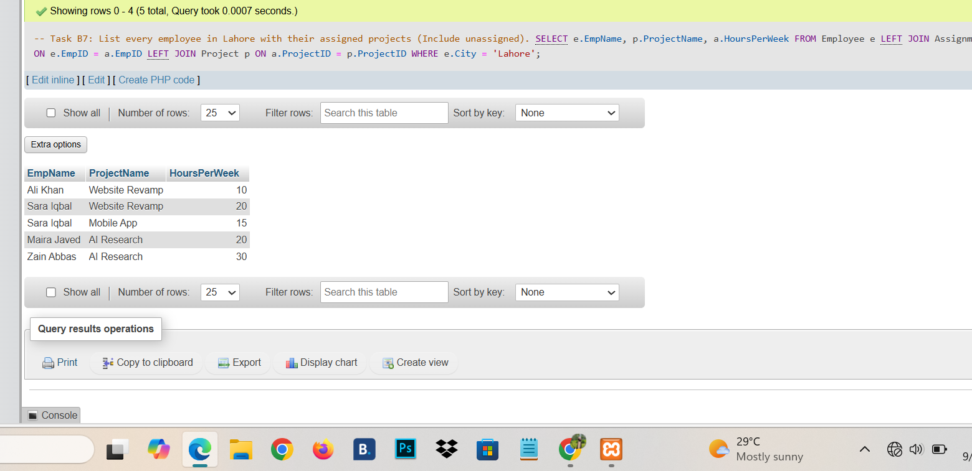
B8: Employee Department different from project department
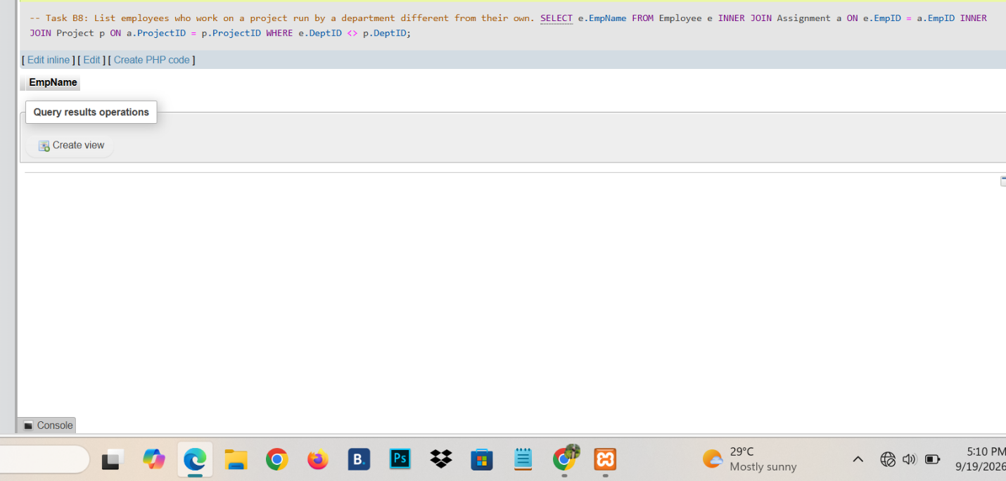
B9:Departnment + project started in 2024
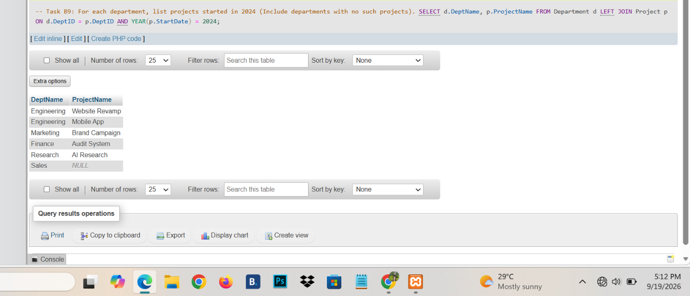
B10: Total weekly hours per employee
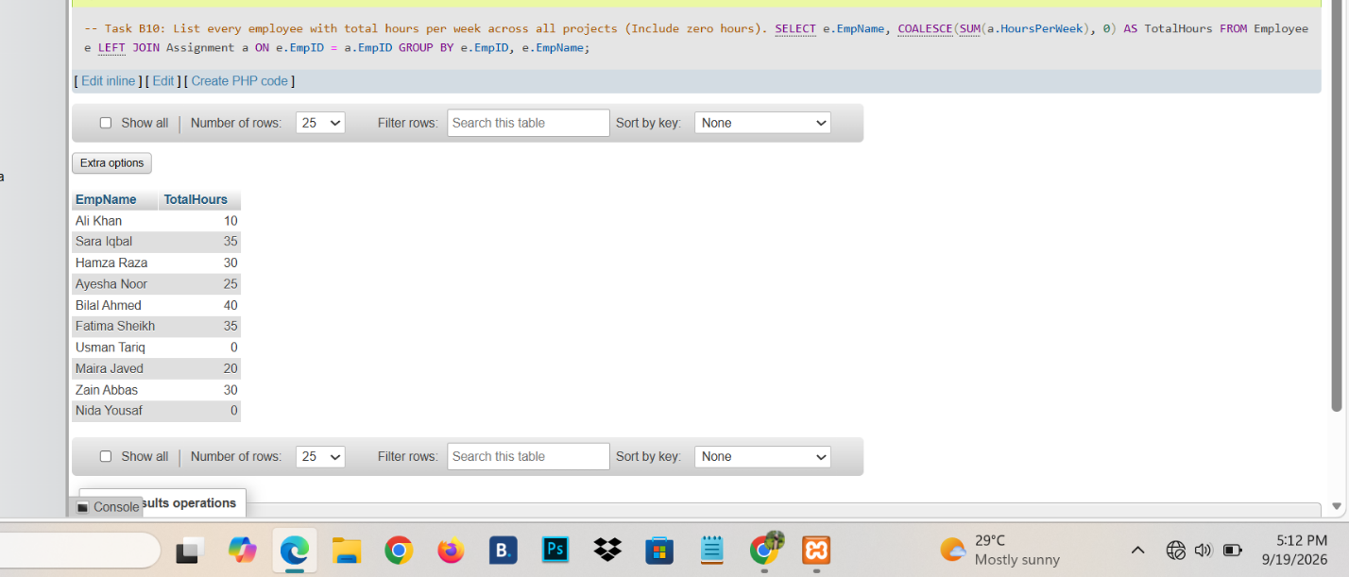

Part C: Assessment :
Create Table :
Author
Book
Member
Loan

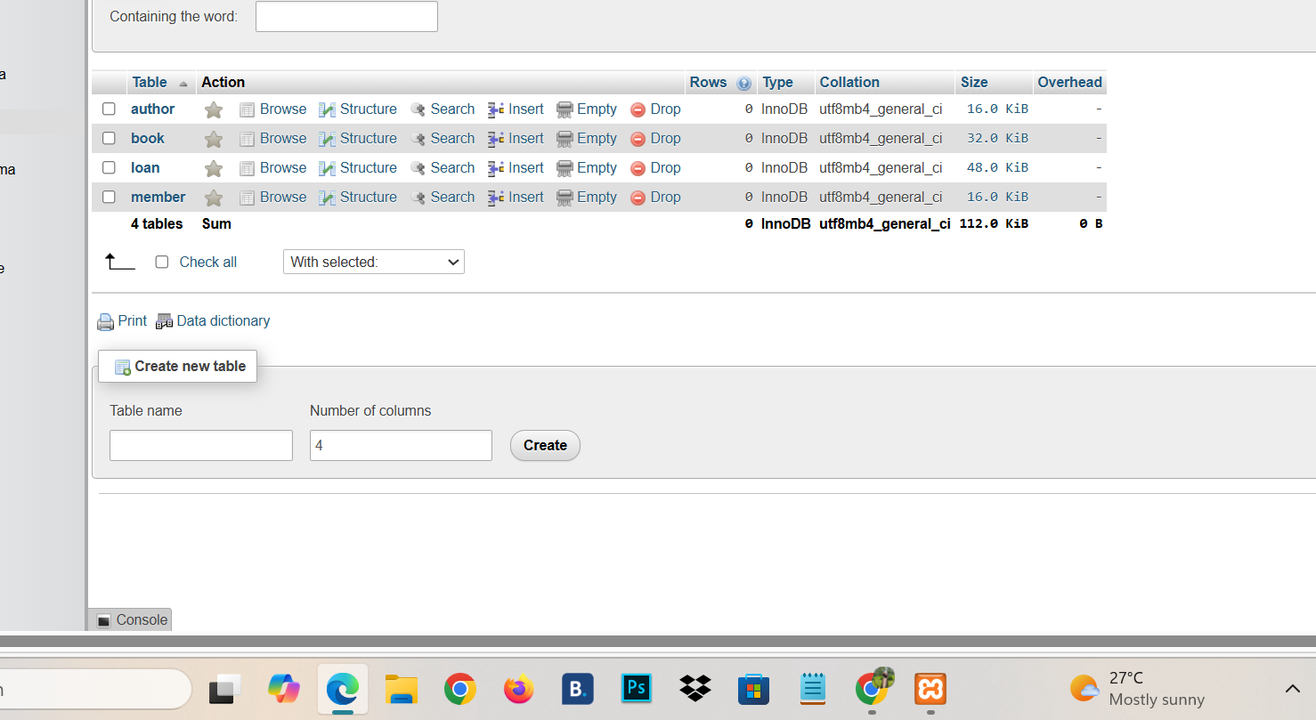
Inserting data

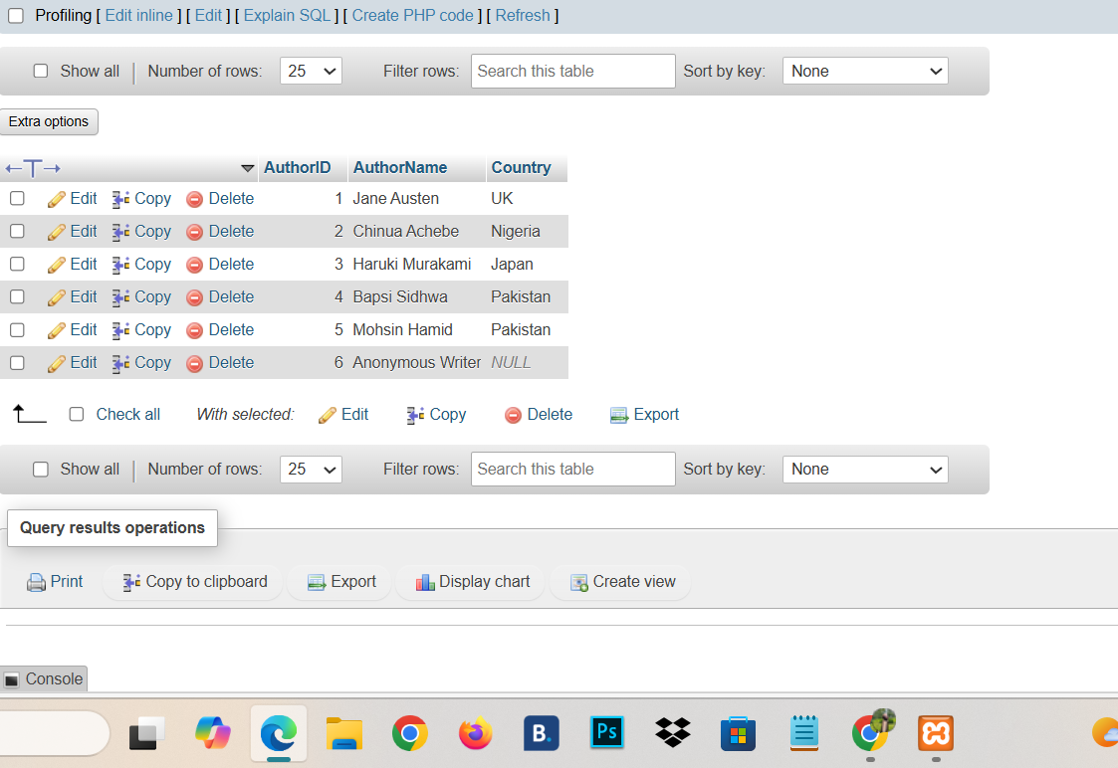
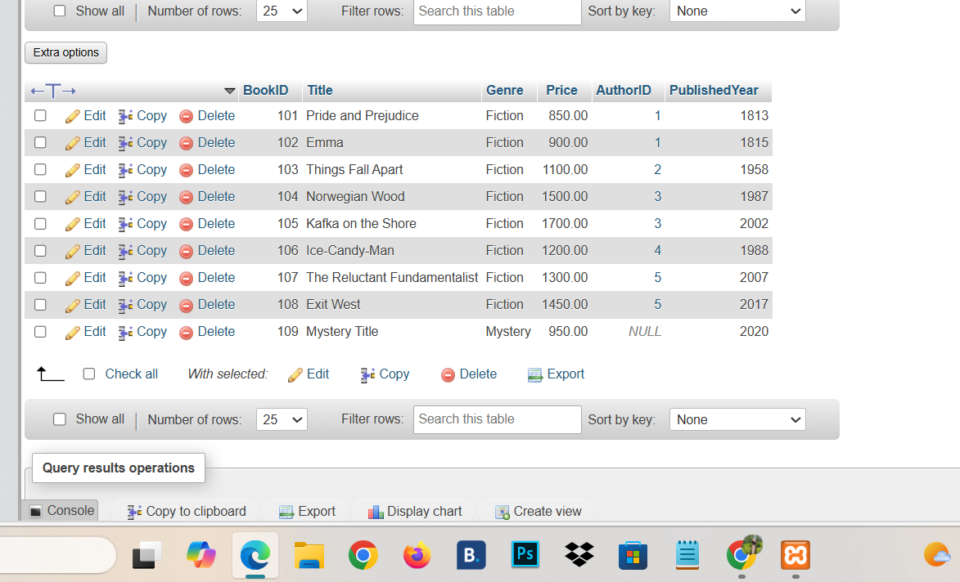

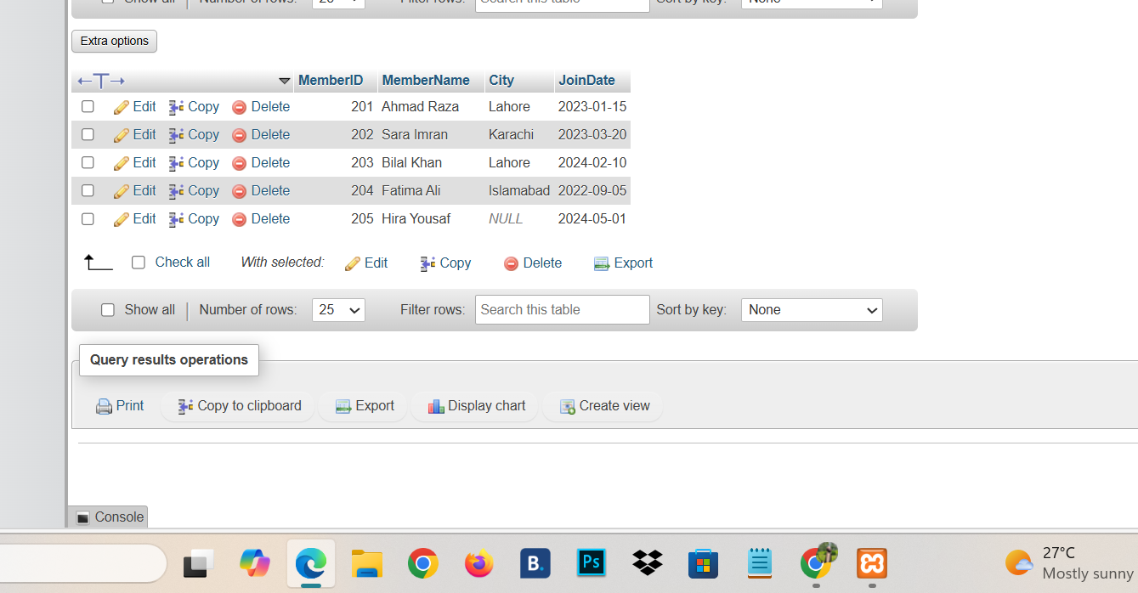

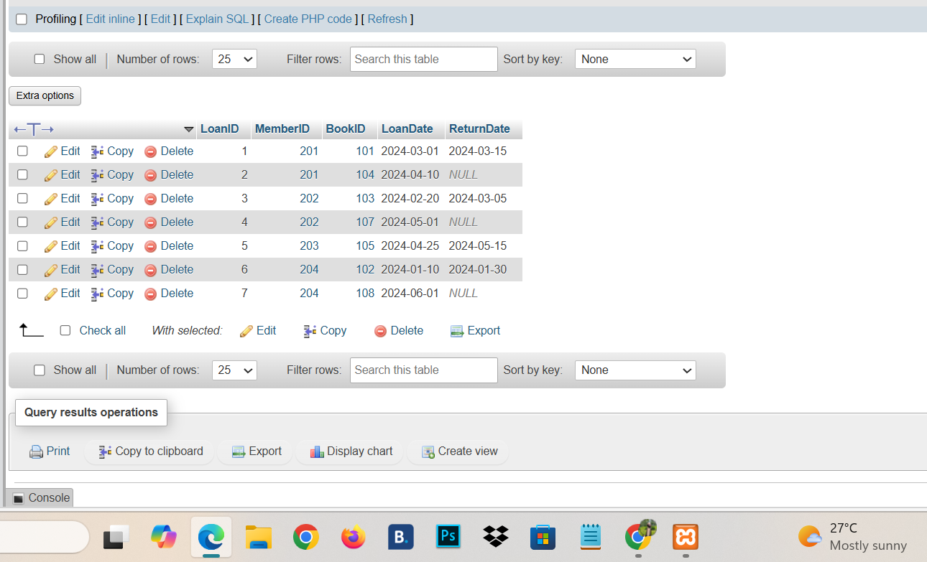
Q1; Show Every Book with Author name and country?
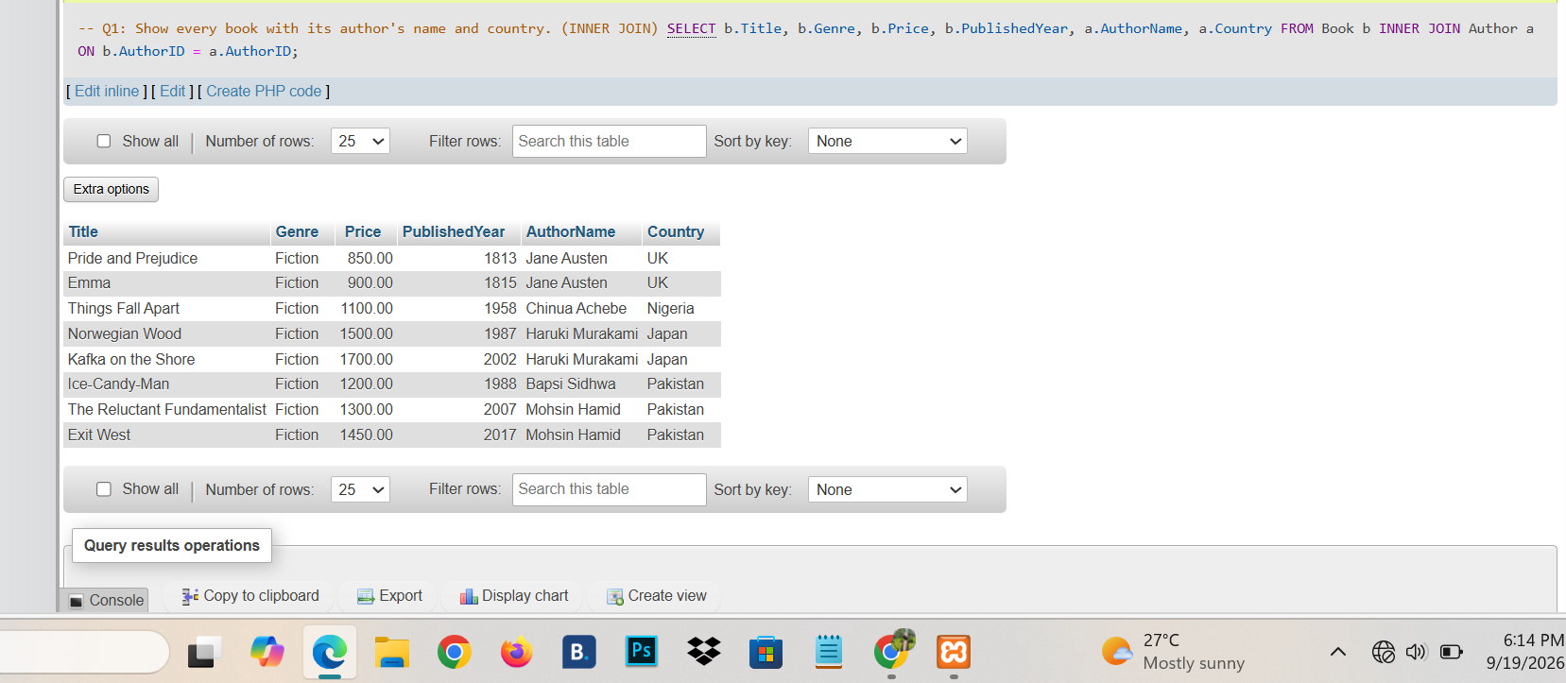
Q2: Show every author with their books ?
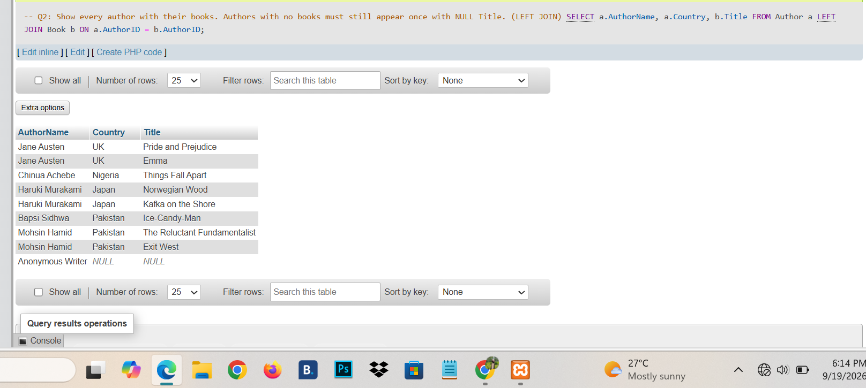
Q3: List member who have never borrowed book?
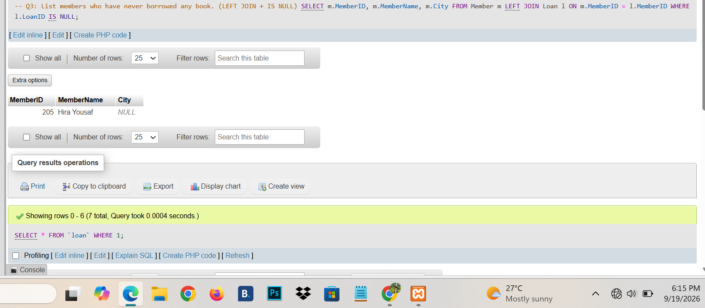
Q4: List Every Loan with the member name ,book title,and author name ?
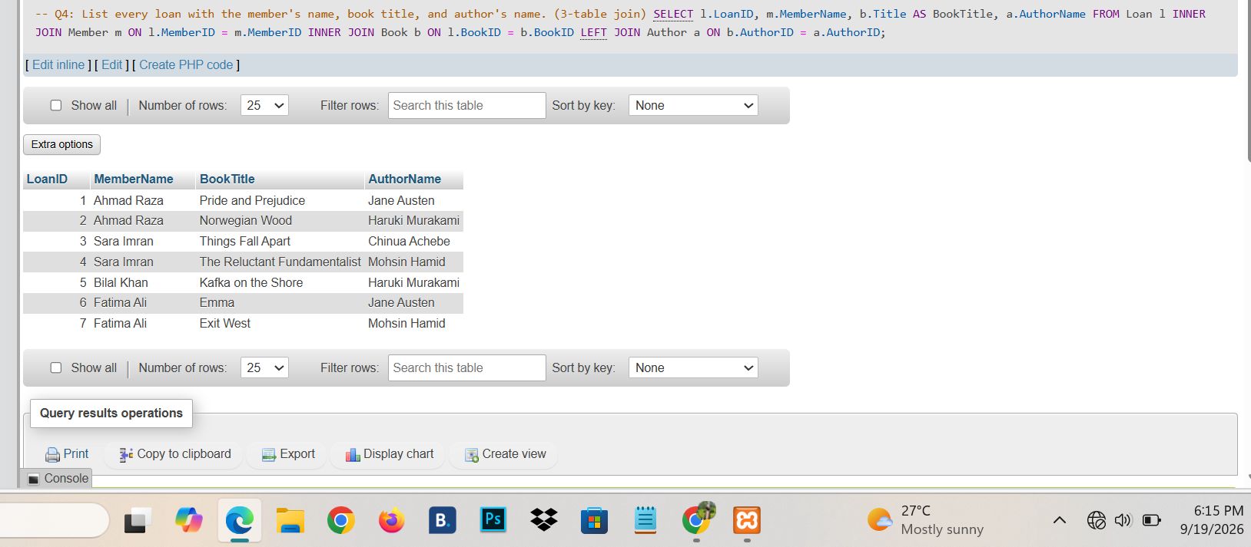
Q5:List Currrently borrowed Books ?
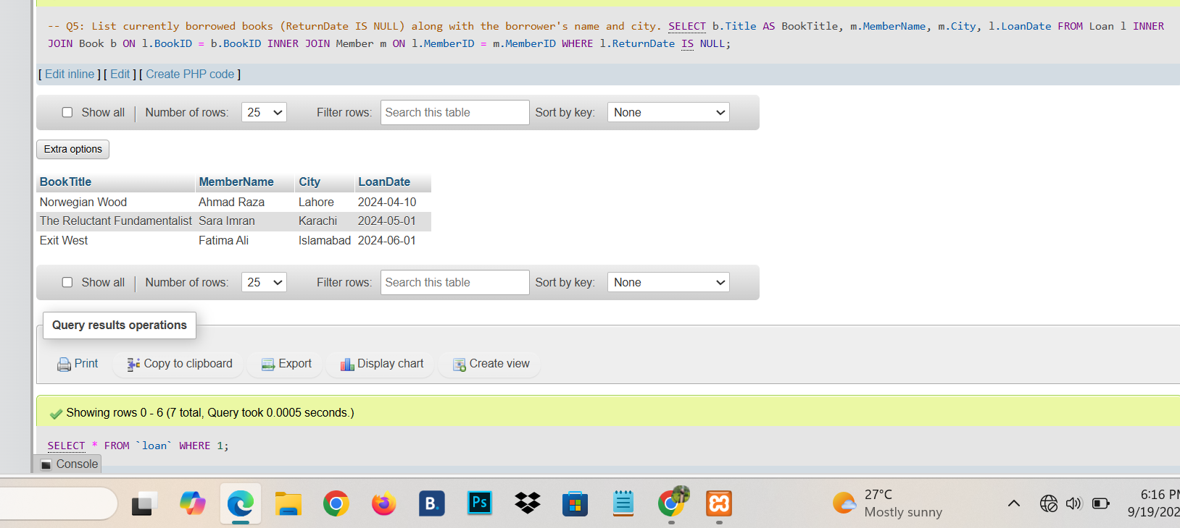
Q6: list Every Pakistani author and title of their book?
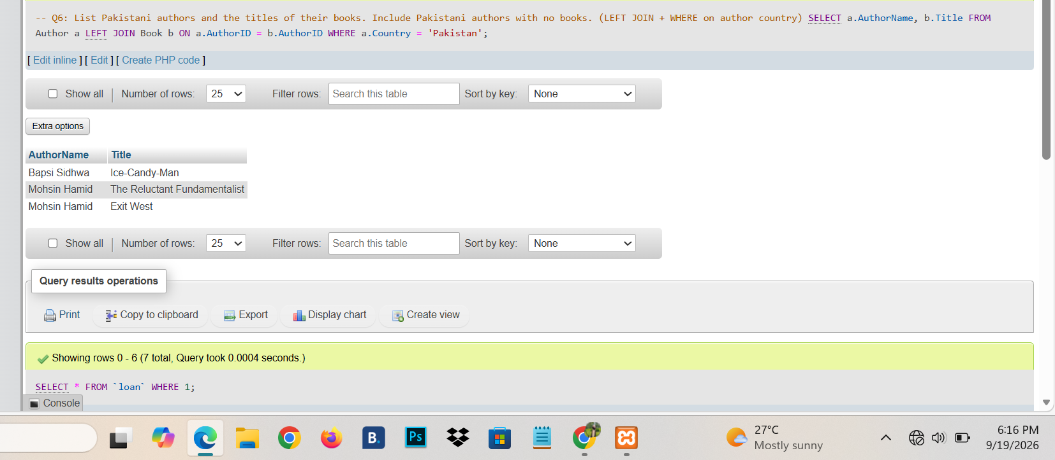
Q7:List every book together with the name of all the member ?
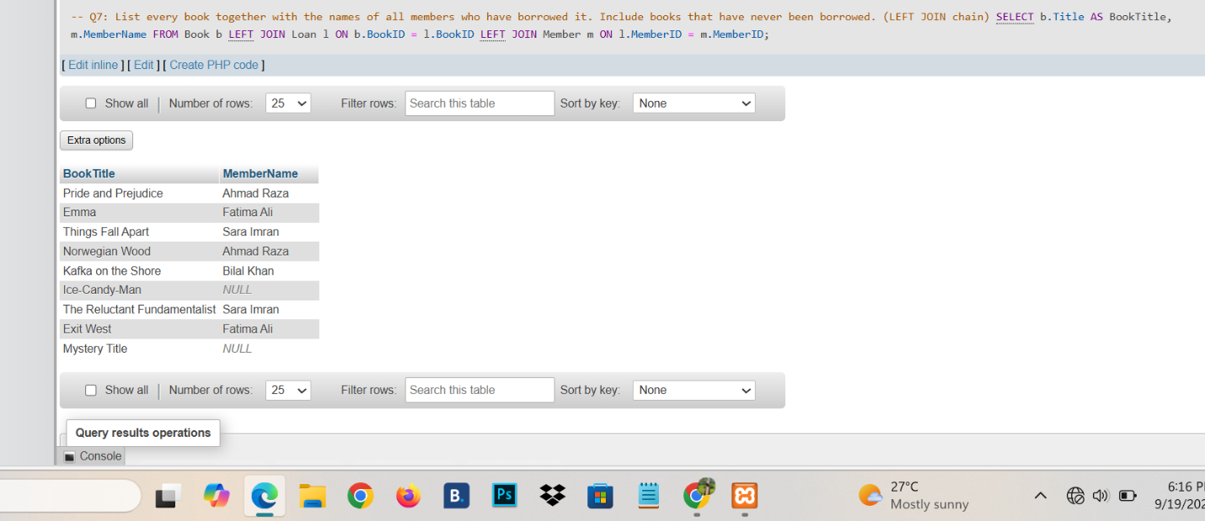
Q8: Find Author whose Book are never Borrowed?
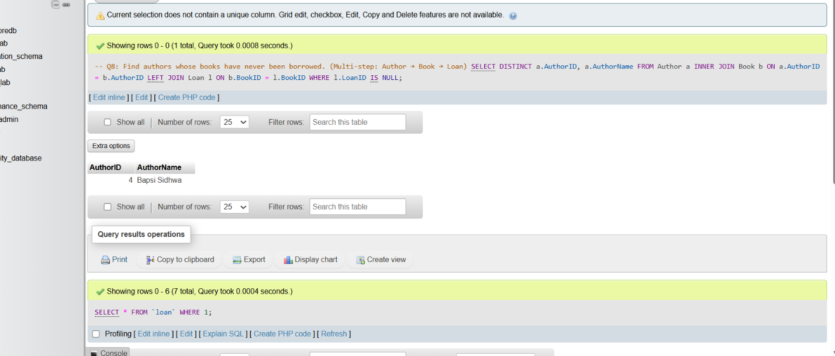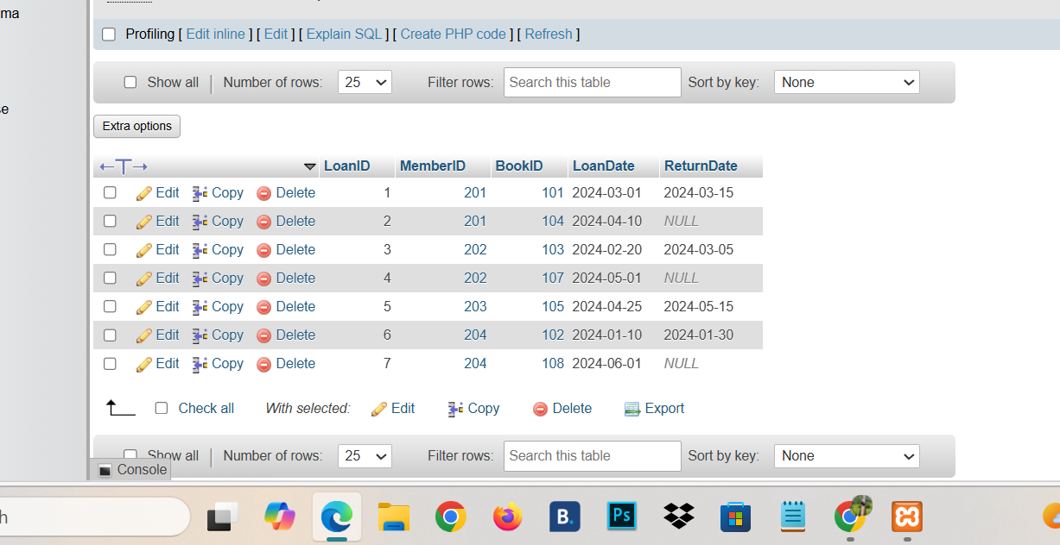
Q9: Produce a full outer join?
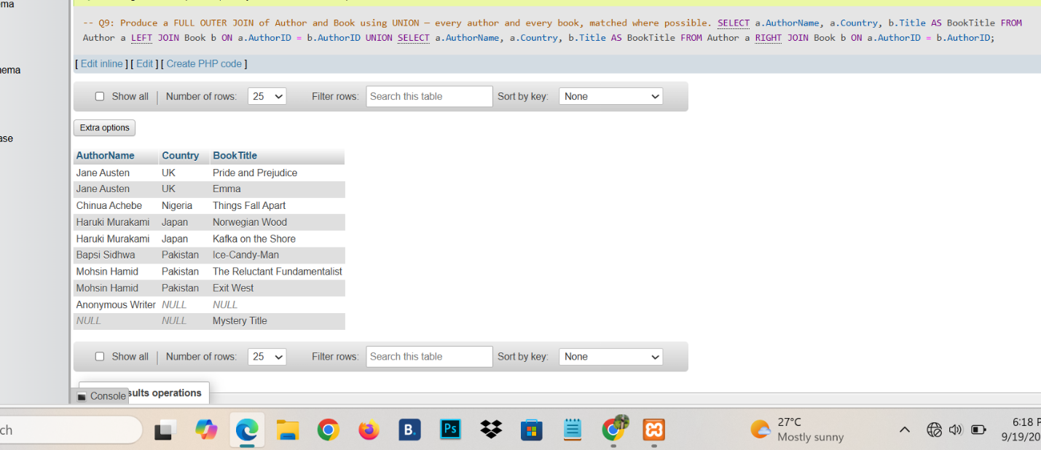
Q10: list member who have borrowed books written by Pakistani aurther ?
